**WEEK-07 HANDS-ON**

**REACT**

**Code-9:**

Create a React Application named “cricketapp” with the following components:

Code:

**OUTPUT:**

**CODE-10:**

Create a React Application named “officespacerentalapp” which uses React JSX to create elements, attributes and renders DOM to display the page.

Code:

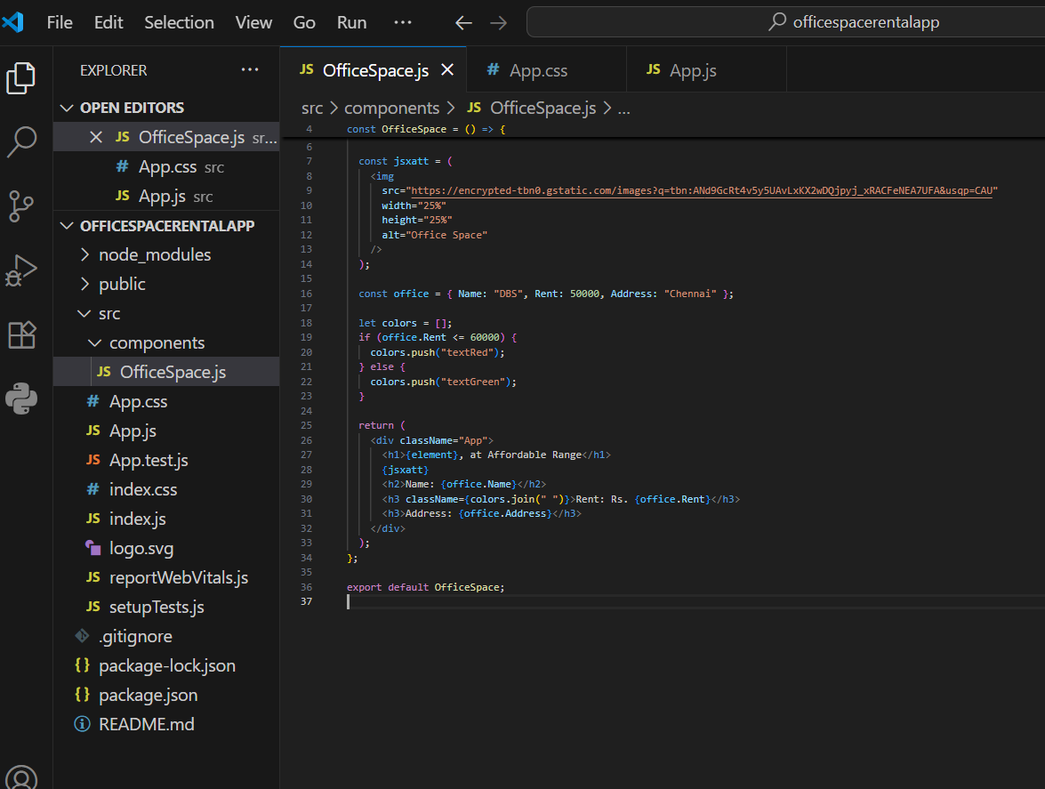

**output:**

**Code-11:**

Create a React Application “eventexamplesapp” to handle various events of the form elements in HTML.

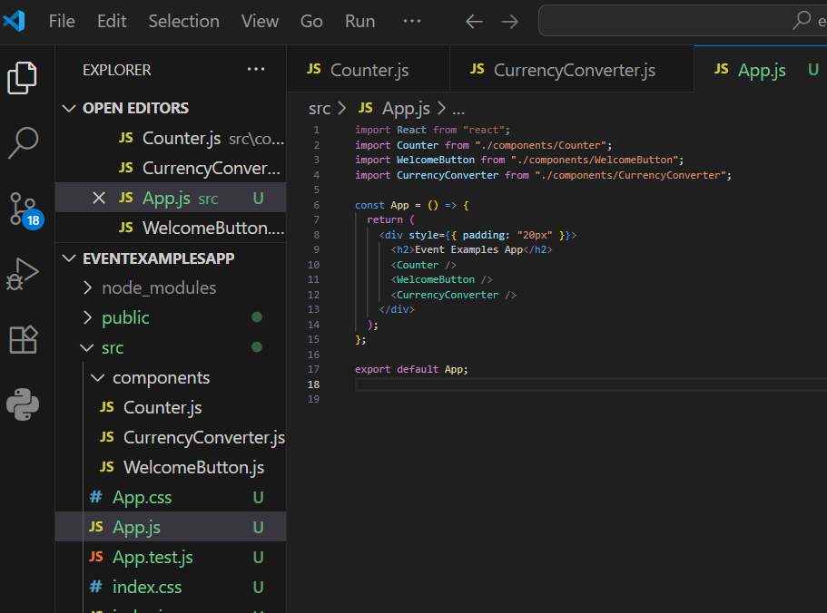

**output**

**Code-12:**

Create a React Application named “ticketbookingapp” where the guest user can browse the page where the flight details are displayed whereas the logged in user only can book tickets.

The Login and Logout buttons should accordingly display different pages. Once the user is logged in the User page should be displayed. When the user clicks on Logout, the Guest page should be displayed.

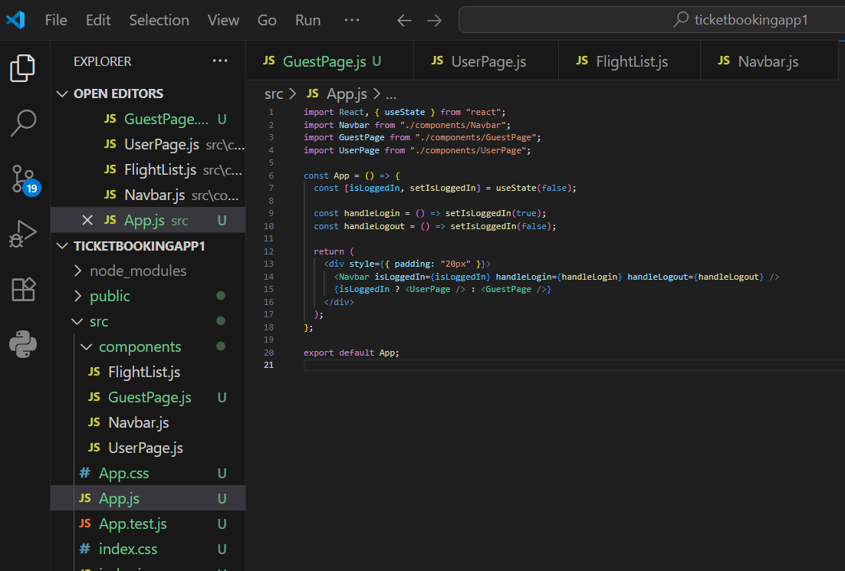

output:

**Code-13:**

Create a React App named “bloggerapp” in with 3 components.

1. Book Details
2. Blog Details
3. Course Details

Output:

**Code-14:**

Create a React App named “ticketraisingapp” which will help to raise a complaint and get it resolved.

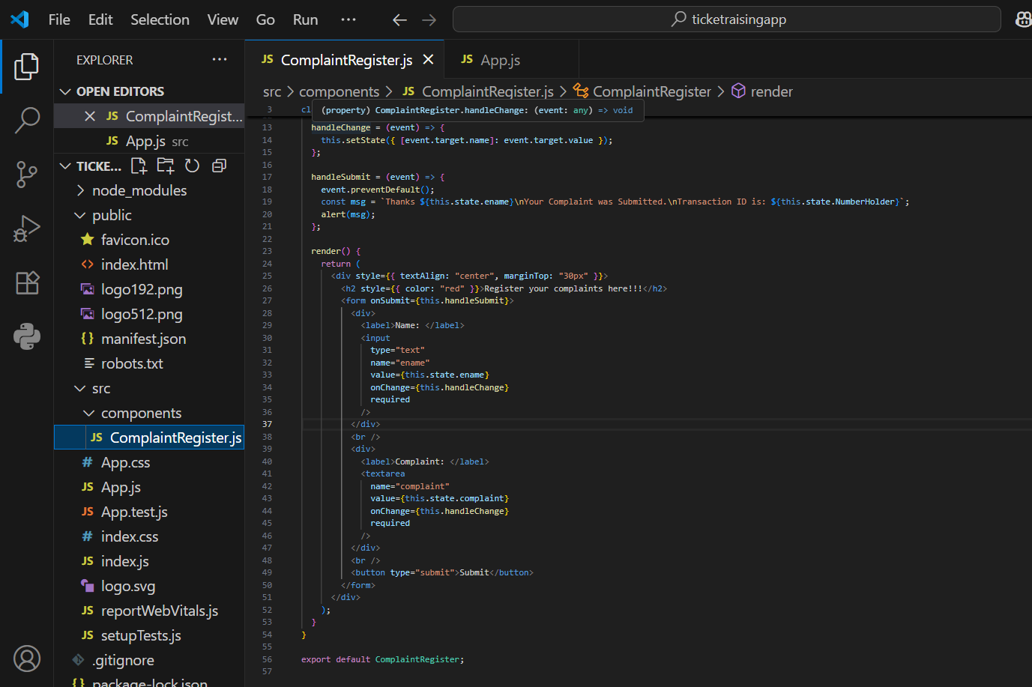

Output:

**Code-16:**

Create a React App named “mailregisterapp” which will have a component named “register.js”. Create a form which accepts the name, email and password and validate the fields as per the following:

1. Name should have atleast 5 characters
2. Email should have @ and .

Password should have atleast 8 characters

Code:

**Register.js:**

import React, { Component } from "react";

class Register extends Component {

constructor(props) {

super(props);

this.state = {

name: "",

email: "",

password: ""

};

}

handleChange = (event) => {

this.setState({ [event.target.name]: event.target.value });

};

handleSubmit = (event) => {

event.preventDefault();

const { name, email, password } = this.state;

// Validation

if (name.length < 5) {

alert("Full Name must be 5 characters long!");

return;

}

if (!email.includes("@") || !email.includes(".")) {

alert("Email is not valid!");

return;

}

if (password.length < 8) {

alert("Password must be 8 characters long!");

return;

}

alert("Registration Successful!");

};

render() {

return (

<div style={{ textAlign: "center" }}>

<h1 style={{ color: "red" }}>Register Here!!!</h1>

<form onSubmit={this.handleSubmit}>

<div>

<label>Name:</label>

<input

type="text"

name="name"

value={this.state.name}

onChange={this.handleChange}

/>

</div>

<br />

<div>

<label>Email:</label>

<input

type="text"

name="email"

value={this.state.email}

onChange={this.handleChange}

/>

</div>

<br />

<div>

<label>Password:</label>

<input

type="password"

name="password"

value={this.state.password}

onChange={this.handleChange}

/>

</div>

<br />

<button type="submit">Submit</button>

</form>

</div>

);

}

}

export default Register;

**App.js:**

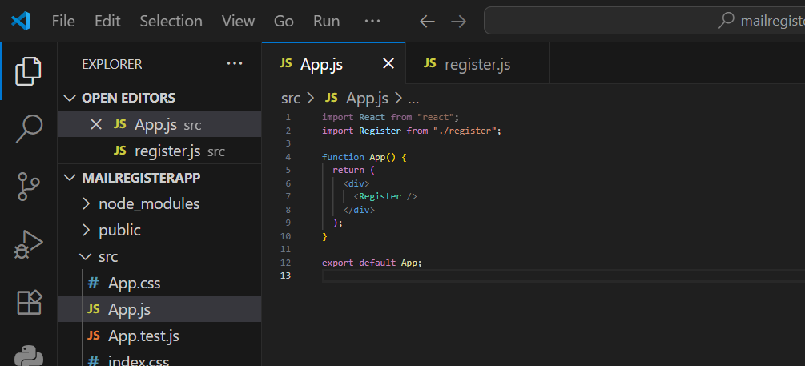

**Output:**

**Code-17:**

**Create a React Application “fetchuserapp” which will retrieve the user details from** [**https://api.randomuser.me/**](https://api.randomuser.me/) **and display the title, firstname and image of a user.**

**Create a component named “Getuser” and in the asynchronous method “ComponentDidMount ()” invoke the URL using fetch method and the response can be displayed in the render method of the component.**

Output:

